**Sign Language Recognition and Generation**

**Problem Statement:**

A reliable and efficient Speech to Sign Language Generation system is crucial for bridging communication gaps between individuals with hearing impairments and those without. This system must interpret spoken words in real-time, considering linguistic nuances, and generate expressive 3D sign language animations and video sequences. Such a solution will enhance accessibility and promote inclusive communication for both deaf and non-signing individuals.

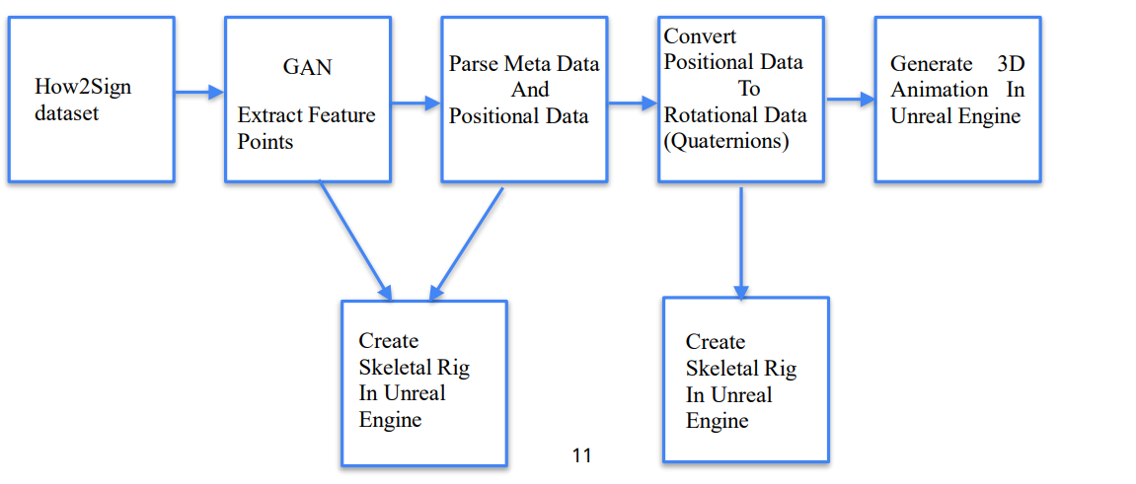

**Proposed Methodology :**

1. How2Sign Dataset: Contains metadata and positional rig values for each sign language word.
2. GAN Extract Feature Points: Use a Generative Adversarial Network (GAN) to extract key feature points from the dataset. This stephelps in identifying crucial points necessary for accurate animation.
3. Parse Metadata & Positional Data: Extract the signed word, signer information, timestamps, and feature point data from the GAN output.
4. Create Skeletal Rig in Unreal Engine: Define the skeleton with bones and their parent-child relationships in Unreal Engine. 12 Proposed Methodology
5. Convert Positional Data to Rotational Data: For each bone in each frame, compute the rotation (quaternion) required to transform from its rest pose tothe given feature point data.Ensure transformations respect the hierarchical nature of the skeletal rig.
6. GenerateAnimation in Unreal Engine using Editor Scripting: Use Unreal Engine’s editor scripting to create animation sequences based on the computed quaternions. Apply the animationsto the skeletal rig.